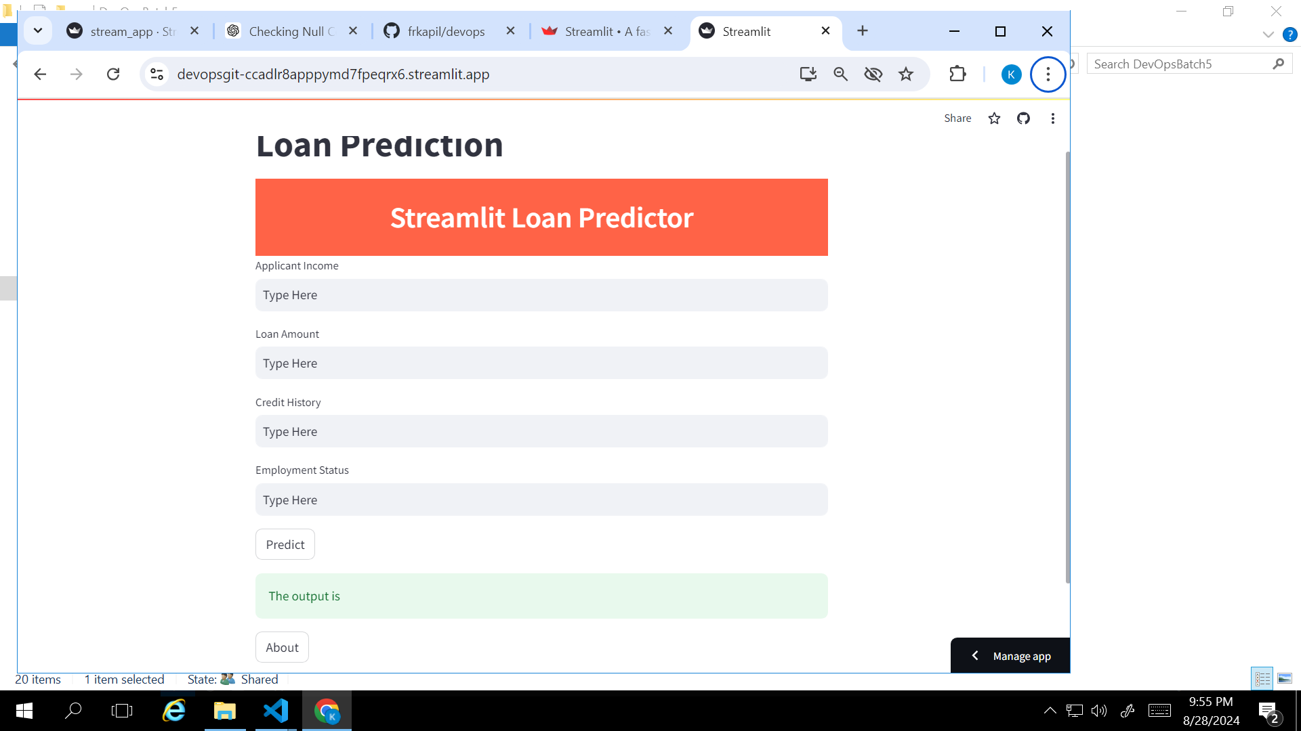

Streamlit gui for loan prediction model

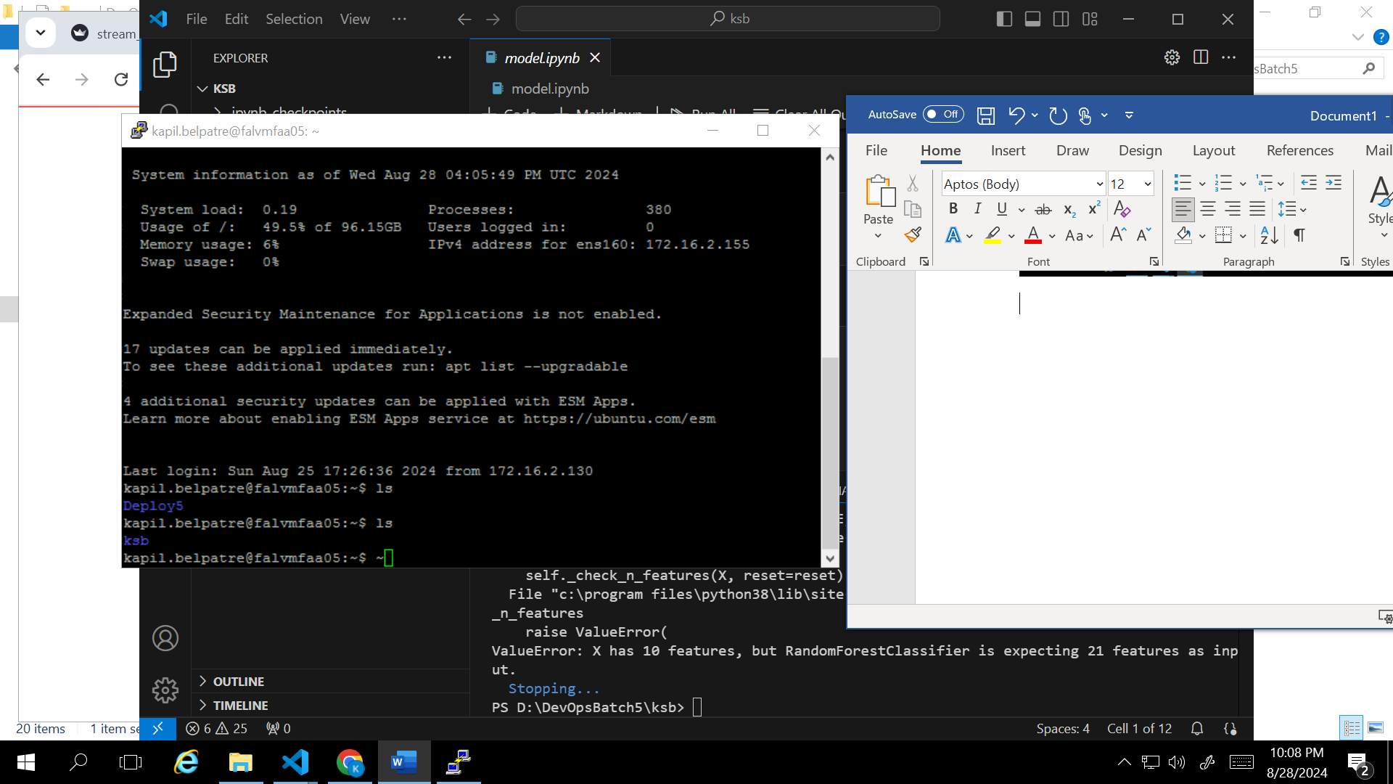

Login through putty and added folder ksb which has all files related to model.

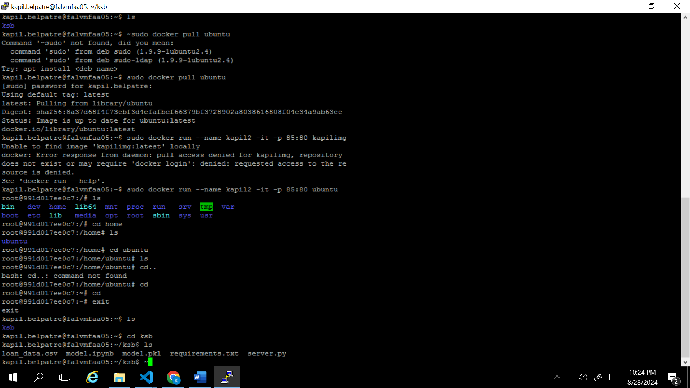

Login through putty and added folder ksb which has all files like csv, model, req.txt and server.py

Docker image kapil_loan_model is commited to docker hub

